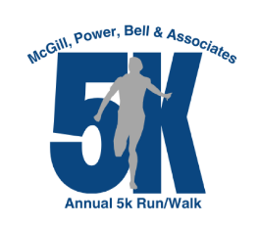

MPB Foundation Annual 5K Run/Walk

Sponsorship Form

September 7, 2024 @ 9:30am – Bean's Trailhead @ Ernst Trail

Organization Name:

Address:

City, State, Zip code:

Contact Person:

Contact Email:

Phone Number:

Website Address:

1. Sponsorship level (please circle one):

Platinum Sponsor Gold Sponsor Silver Sponsor Bronze Sponsor

1. Sponsor can choose to have company name or submit a logo, dependent on sponsorship level. Please write your company name exactly how you would like it to appear on the website, signage, etc.:

Artwork and logos should be submitted to [jpanchura@mpbcpa.com](mailto:jpanchura@mpbcpa.com) by August 1st.

1. Participants that receive complementary race entries as part of their sponsorship can register for the 5K by providing participant information to Julia Fair at [jfair@mpbcpa.com](mailto:jfair@mpbcpa.com).
2. Checks can be made payable to the MPB Foundation and mailed to: 180 Mercer St. Meadville, PA 16335. Please mail checks by July 31, 2024.

Please contact Julia Fair with questions or for additional information on sponsorships at 814-724-5890 or email to [jfair@mpbcpa.com](mailto:jfair@mpbcpa.com).