# Erosion and Sediment Control (E&S) Plan Template for a Timber Harvesting Operation

This E&S Plan template only applies to timber harvest activities, as defined by 25 Pa. Code §102.1, which are not part of a larger development or conversion project.

**1. GENERAL INFORMATION**

Date

A. Location      

Municipality County

B. Timber sale area =       acres

C. Landowner/Agent            

Name Home Phone Work Phone

Street Address

           

City State Zip Code Signature of Landowner/Agent

D. Person(s) responsible for construction and maintenance of erosion and sediment control BMPs during and after earth disturbance activities.

(NOTE: If duties are assigned to more than one party, list all others under Section 12 of this plan.)

Name Home Phone Work Phone

Street Address

City State Zip Code Signature of person(s) responsible

E. Erosion and Sediment Control Plan prepared by:

      Phone

Name

Street Address

City State Zip Code Signature of Plan Preparer

**2. TOPOGRAPHICAL MAP**

The map must include the location of the project with respect to roadways, streams, wetlands, lakes, ponds, floodplains, type and extent of vegetation and other identifiable landmarks. A United States Geologic Service (USGS) quadrangle map may be used to show the existing topographical features of the project site and the immediate surrounding area. The map scale must be large enough to clearly depict the topographical features of the project. Enlargements of the USGS quadrangle map are sufficient. The scale and north arrow must be plainly marked. A complete legend of all symbols used on the map must also be included.

**3. SOIL MAP**

Soils information is available in soil survey reports or online at <https://websoilsurvey.nrcs.usda.gov/app/>. For additional information, contact your local county conservation district office. The soils drainage classes must be examined to determine areas with the best drainage for the placement of haul roads and log landings, and to determine proper retirement treatments. Provide the following soils information for all disturbed areas.

|  |  |  |  |  |  |
| --- | --- | --- | --- | --- | --- |
| Map Symbols |  | **Soil Series** | **Limiting Characteristics1**  **That May Apply to Timber Harvesting Activities**  **(Check as Appropriate)** | | |
| **Erosion Hazards2** | | |
| **Slight** | **Moderate, severe** | **Seasonably Wet3** |
|  |  |  |  |  |  |
|  |  |  |  |  |  |
|  |  |  |  |  |  |
|  |  |  |  |  |  |
|  |  |  |  |  |  |

1 Soils with a moderate or severe erosion hazard or are seasonably wet are poor choices for log landing and road locations, and, if possible, alternatives should be considered.

2 The degree or ease by which soil particles can be detached from the soil surface. Moderate or severe ratings require additional consideration of soil erosion and sediment control BMPs during logging and road construction.

3 Somewhat poorly drained soils remain wet for a longer period after rain and would be susceptible to disturbance. These soils may be hydric, indicating a possible wetland. They may have to be logged during dry seasons, when the profile may be relatively dry, or when the soils are frozen. They are poor choices for log landing and road locations, and, if possible, alternate areas should be considered.

**4. SKETCH MAP**

**The characteristics of the earth disturbance activity.** Sketch maps can be included on the topo map in Section 2. The limits of the harvesting area must be shown on the sketch map. Such information as the limits of clearing and grubbing and the areas of cuts and fills for roads and landings, and other proposed disturbances for the timber harvesting area are to be included. Earth disturbances located within a floodway (as defined by a FEMA map, or 50 ft. where not defined) may require a Chapter 105 permit. The following should be clearly shown on the sketch map:

• Project Boundary • Wetland Crossings • North Arrow

• Stream Crossings • Landings • Haul Roads

• Existing Roads • Skid Roads • Section 8 BMPs

• Equipment Maintenance/Fueling Areas

**5. RECEIVING SURFACE WATERS**

All streams in Pennsylvania are classified based upon their designated and existing uses and water quality criteria. Designated uses for waters of this Commonwealth are found in 25 Pa. Code §§ 93.9a-z, found online at http://[www.pacode.com/secure/data/025/chapter93/chap93toc.html](http://www.dep.state.pa.us). Existing uses of waters of this Commonwealth are found DEP’s website ([www.dep.pa.gov](http://www.dep.pa.gov)), Keyword Search: Statewide Existing Use. The county conservation district office can also supply this information. Identify the surface waters, including wetlands, likely to receive direct runoff within or from the timber harvest area:

|  |  |  |
| --- | --- | --- |
| Name |  | Designated/Existing Use |
|  |  |  |
|  |  |  |
|  |  |  |
|  |  |  |
|  |  |  |

Has application been made for required Chapter 105 permits? Yes  No  Not Applicable

At all stream crossing locations, runoff must be directed to a sediment removal area (e.g. filter strip, straw bale, silt fence, sump, or trap for treatment). Waterbars and/or broad-based dips should be installed and maintained as required on the approaches to the stream crossing.

**6. ESTIMATED DISTURBED AREA**

|  |  |  |  |  |  |  |  |  |  |  |  |
| --- | --- | --- | --- | --- | --- | --- | --- | --- | --- | --- | --- |
|  |  | **Total Length (ft)** |  | **Average Width (ft)** |  | **Area (sq ft)** |  | | | | |
| Haul Roads |  |  | x |  | = |  |  | | | | |
| Skid Roads |  |  | x |  | = |  |  | | | | |
| Landings |  |  | x |  | = |  |  | | | | |
|  |  |  |  |  |  |  |  | | | | |
|  |  |  |  | Total Area (sq. ft.) | = |  | ÷ 43,560 sq ft/ac | = | |  | *** |
|  | | | | | | | | | Acres disturbed by earth disturbance activities | | |

*** If the total area of earth disturbance activities (sum of area disturbed by haul roads, skid roads and landings) consists of 25 acres or more, a Chapter 102 Erosion and Sediment Control Permit (ESCP) must be obtained. Please contact the Department or authorized conservation district for assistance.

The following points should be considered when laying out a road system:

* **Construct only as much road as necessary**. Minimize clearing. Keep road width to the minimum necessary for safe and efficient operation.
* **Terminal points** – Locate the start and end of the road system using the best access that is safe and visible from public roads. Locate landings away from streams and wet areas. Install rock construction entrances as shown in Section 8.K. **NOTE: A highway occupancy permit may be required**.
* **Grades** – Haul roads with a maximum slope of 10% and a minimum of 2% are usually the easiest to maintain. Where absolutely necessary, grades of 15 to 20% can be used for short distances. Follow the contour as much as possible. Use waterbars (Section 8.B) on skid roads whenever it is not possible to avoid grades of 20% or more.
* **Topography** – Roads on moderate side hills are easiest to build and maintain. Avoid steep slopes wherever possible.
* **Drainage** – Construct roads to drain at all times, such as using crowned or insloped surfaces. Install ditch relief culverts as shown in Section 8.A or broad-based dips as shown in Section 8.E. Turnouts as shown in Section 8.C may be used on low-side ditches to direct flow into filter strips.
* **Grading** – Minimize cut and fill work, and keep slopes at stable angles. Remove trees from tops of cuts, when the root system is undercut, and seed and mulch cut and fill slopes promptly (Section 8.L). Do not fill into open sinkholes, waterways, wetlands, floodways or other sensitive areas.
* **Obstacles** – Design the road system to go around springs, seeps, wetlands, poor drainage areas, ledges, and rocky areas wherever possible.
* **Distances from Streams** – Filter strips should be maintained along stream corridors to provide sediment filtration and maintain stream temperatures (Section 8.F). Wherever sufficient filter strips are not possible between roadways and receiving surface waters, install BMPs, such as silt fence (Section 8.G) as the roadway progresses. See Section 8.F for minimum filter strip widths.
* **Stream Crossings** – Minimize the number of stream crossings. Cross at a 90 degree angle and approach the stream at as gentle a slope as possible. **NOTE: A Chapter 105 permit may be required.**
* **Old roads** – It is often possible to use existing roads and thereby lessen the soil disturbance. However, to avoid problems, carefully evaluate the road’s suitability for upgrading.
* **Landings** – Locate landings in relation to the main haul road. Then lay out the skid road and trail approaches on a low grade to the landings. Minimize the number and size of landings as much as possible.
* **Size and duration of sale** and the anticipated season of harvest.
* **Floodways and wetlands** – Avoid encroaching on wetlands. Roadway and landing construction within floodways and wetlands may require Chapter 105 permits.
* **Water Control Structures** – Carefully plan the use of broad based dips (Section 8.E), waterbars (Section 8.B), culverts (Section 8.8A), and ditches to maintain existing flow patterns and minimize the amount of runoff being conveyed by roadways and roadside ditches.
* **NEVER SKID THROUGH OR ACROSS STREAM CHANNELS AND AVOID WETLANDS, SPRINGS OR SEEPS.**

**7. RUNOFF**

**The amount of runoff from the timber harvest area and its upstream watershed area.** You do not have to provide runoff calculations, unless you plan to use BMPs different from those described in Section 8. If you use different BMPs, your calculations must include an analysis showing any impact that runoff may have on existing downstream watercourses and their resistance to erosion.

**8. DESCRIPTION OF EROSION AND SEDIMENT CONTROL MEASURES**

The following standard BMP drawings and recommended spacings (Sections 8.A-8.L) have been provided to fulfill the requirements of this plan and satisfy Chapter 102 regulations. If you plan to use any of these recommended BMPs, please check the appropriate boxes for Sections A through L and include their location on the sketch map (Section 4). If you plan to use alternative BMPs, you must provide drawings showing the details, specifications and spacing (Section 7). The standards and construction details referenced are from the Department’s *Erosion and Sediment Pollution Control Program Manual* (Document #363-2134-008, March 2012). Additional approved BMPs and specifications can be found at DEP’s website, Keyword Search: E&S Resources.

Timber harvesting projects that require a Chapter 102 ESCP and occur within a special protection watershed or EV wetland will be required to implement nondischarge alternatives and antidegradation best available combination of technologies (ABACT) BMPs. Refer to Chapter 17 of the *Erosion and Sediment Pollution Control Program Manual* for more information.

### A. Ditch Relief Culvert (Cross Drains)

Design Standards

* Minimum diameter for any culvert is 12”; otherwise culvert shall be sized for anticipated peak flow. Place culvert so bottom is at same level as bottom of ditch or adjoining slope. Culverts shall be placed with a slope of 2 to 4%. Lower end shall be at least 2” below upper end and at ground level.
* Extend culvert 12” beyond base of road fill on both sides. Firmly pack fill around culvert, especially the bottom half.
* Provide suitable outlet protection and, where appropriate, inlet protection.
* NOTE: This detail may be used for ditch relief culverts and for crossings of roadside ditches. It is not appropriate for stream crossings.
* For steep slope (>2H:1V) outfalls, a minimum 20 foot long R-5 apron is recommended for temporary access roads where the recommended culvert spacing is used. For permanent access roads, a minimum R-6 rock size is recommended.

Maintenance

* Inspect culvert(s) weekly: remove any flow obstructions and make necessary repairs immediately.

**Will this BMP be used?**  **Yes**  **No**

**Will recommended spacing be used?  Yes  No**

|  |  |  |  |  |  |  |
| --- | --- | --- | --- | --- | --- | --- |
| **Table 1. Ditch relief culvert spacing for temporary access roads** | | |  | **Table 2. Ditch relief culvert spacing for permanent access roads** | | |
| Road Grade (% Slope) | Recommended Spacing (ft) | Alternative Spacing (ft)* |  | Road Grade (% Slope) | Recommended Spacing (ft) | Alternative Spacing (ft)* |
| 2 | 300 |  |  | 2 | 500 |  |
| 3 | 235 |  |  | 4 | 400 |  |
| 4 | 200 |  |  | 6 | 350 |  |
| 5 | 180 |  |  | 8 | 300 |  |
| 6 | 165 |  |  | 10 | 250 |  |
| 7 | 155 |  |  | 12 | 200 |  |
| 8 | 150 |  |  | 14 | 150 |  |
| 9 | 145 |  |  | * If alternative spacings are used, please make sure reasons for their use are explained. | | |
| 10 | 140 |  |  |
| 12 | 135 |  |  |
| * If alternative spacings are used, please make sure reasons for their use are explained. | | |  |

### Figure 1. Standard Construction Detail for Ditch Relief Culverts

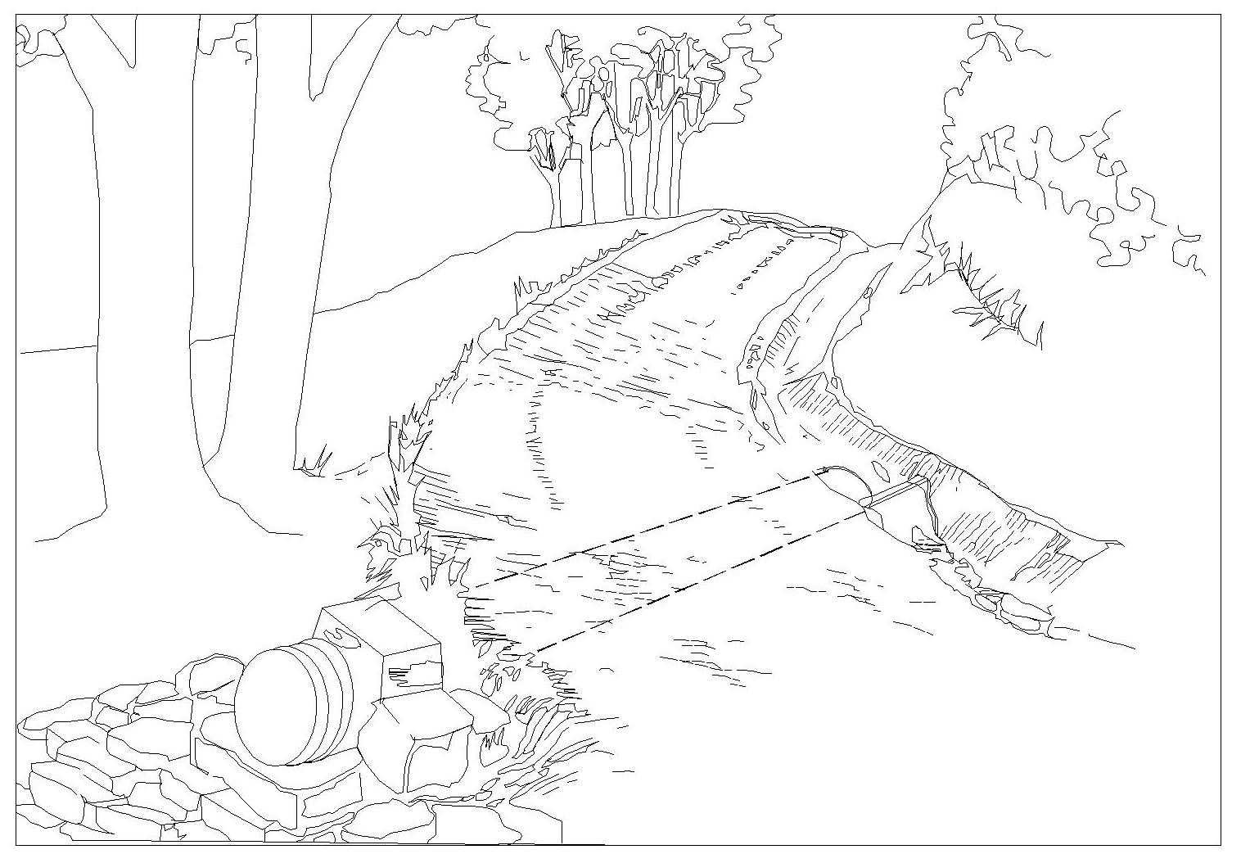

Figure 1.  Standard Construction Detail for Ditch Relief Culverts

B. Waterbars

Design Standards

* Waterbars are typically used to control stormwater runoff on retired access roads and skid trails. They are not recommended for active access roads or skid trails due to the difficulty of moving equipment over them as well as the need for continual maintenance due to damage from traffic.
* Where waterbars are not practical on active access roads or skid trails, other BMPs such as Water Deflectors (Section 8.D) or Broad-based Dips (Section 8.E) can be used to control runoff.
* Waterbars shall be placed at a slight angle to allow drainage and discharge to a stable area.

Maintenance

* Waterbars shall be inspected weekly (daily on active roads) and after each runoff event. Damaged or eroded waterbars shall be restored to original dimensions within 24 hours of inspection.
* Maintenance of waterbars shall be provided until roadway, skid road, or right-of-way has achieved permanent stabilization.
* Waterbars on retired roadways, skid roads, and right-of-ways shall be left in place after permanent stabilization has been achieved.
* Waterbars that need to be removed during operations should be replaced before leaving the site at the end of the day.

**Will this BMP be used?**  **Yes  No**

**Will recommended spacing be used?  Yes  No**

|  |  |  |
| --- | --- | --- |
| Table 3. Waterbar spacing | | |
| Road Grade (% Slope) | Recommended Spacing (ft) | Alternative Spacing (ft)* |
| 0 – 5 | 250 |  |
| 5 – 15 | 150 |  |
| 15 – 30 | 100 |  |
| 30 & above | 50 |  |
| * If alternative spacings are used, please make sure reasons for their use are explained. | | |

### Figure 2. Standard Construction Detail for Waterbars

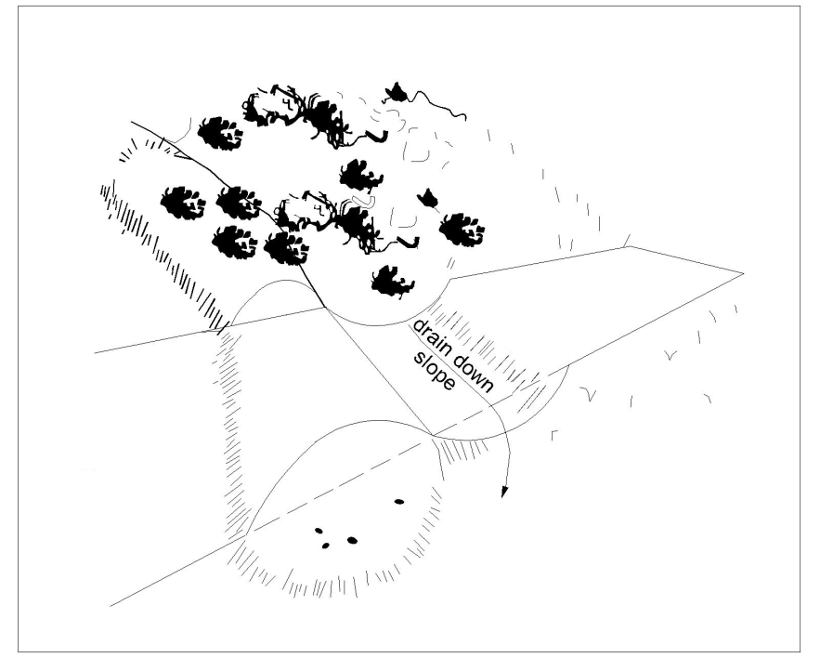

Figure 2.  Standard Construction Detail for Waterbars

### C. Turnouts

Design Standards

* Turnouts should be located so as to take advantage of natural drainage courses or filter strips whenever possible.
* An excavated sump at the end of the turnout can be effectively used to pond and settle out sediment prior to discharging to a vegetated buffer.
* Where a suitable filter strip is not available, a compost filter sock, rock filter or other sediment removal BMP should be installed at the outlet of the turnout.

**Will this BMP be used?  Yes  No**

### Figure 3. Standard Construction Detail for Turnouts

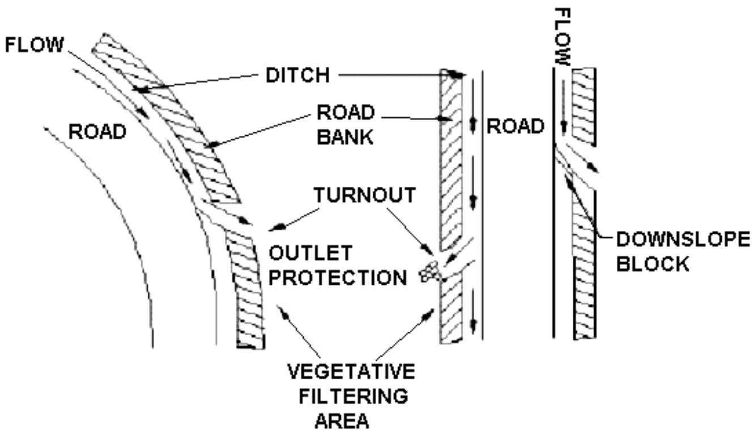

### D. Water Deflector

Design Standards

* Maximum spacing of deflectors shall be as shown in Table 4.

Maintenance

* Deflector shall be inspected weekly and after each runoff event.
* Accumulated sediment shall be removed from the deflector within 24 hours of inspection.
* Belt shall be replaced when worn and no longer effective.

**Will this BMP be used?  Yes  No**

**Will recommended spacing be used?  Yes  No**

|  |  |  |
| --- | --- | --- |
| Table 4. Water Deflector Spacing | | |
| Road Grade (% Slope) | Recommended Spacing (ft) | Alternative Spacing (ft)* |
| < 2 | 300 |  |
| 3 | 235 |  |
| 4 | 200 |  |
| 5 | 180 |  |
| 6 | 165 |  |
| 7 | 155 |  |
| 8 | 150 |  |
| 9 | 145 |  |
| 10 | 140 |  |
| * If alternative spacings are used, please make sure reasons for their use are explained. | | |

### Figure 4. Standard Construction Detail for Water Deflectors

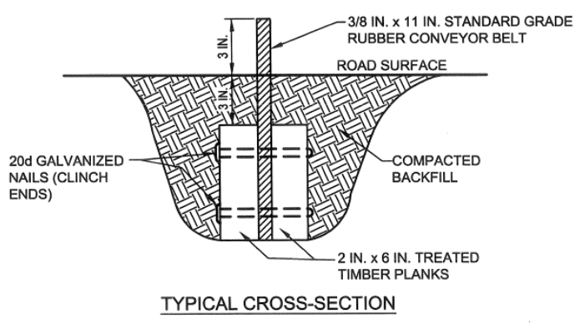 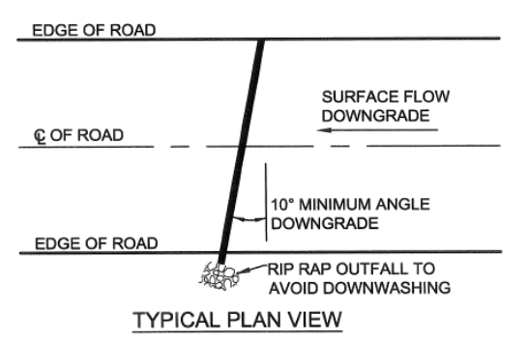

### E. Broad-based Dips

Design Standards

* Broad-based dips shall be constructed to the dimensions shown and at the locations shown on the sketch map (Section 4).
* Dips shall be oriented so as to discharge to the low side of the roadway.
* Maximum spacing of broad-based dips shall be as shown in Table 5.

Maintenance

* Dips shall be inspected daily. Damaged or non-functioning dips shall be repaired by the end of the workday.

### Will this BMP be used? Yes No

### Will recommended spacing be used? Yes No

### 

|  |  |  |
| --- | --- | --- |
| Table 5. Broad-based Dip Spacing | | |
| Road Grade (% Slope) | Recommended Spacing (ft) | Alternative Spacing (ft)* |
| < 2 | 300 |  |
| 3 | 250 |  |
| 4 | 200 |  |
| 5 | 180 |  |
| 6 | 170 |  |
| 7 | 160 |  |
| 8 | 150 |  |
| 9 | 145 |  |
| 10 | 140 |  |
| * If alternative spacings are used, please make sure reasons for their use are explained. | | |

### Figure 5. Standard Construction Detail for Broad-based Dips

**Figure 5.  Standard Construction Detail for Broad-based Dips**

### F. Filter Strip

Design Standards

* A filter strip is a strip or area of vegetation used for removing sediment, organic matter, and other pollutants from runoff and wastewater.
* To be effective, runoff should be in the form of sheet flow and the vegetative cover should be established prior to the earth disturbance activity.
* The suitability of natural filter strips should be document by photo(s) as part of the plan.
* Meadow vegetation should be an existing, well-established, perennial grass.
* Forest filter strips consist of vegetation that is predominantly native trees, shrubs and forbs along surface waters that is maintained in a natural state or sustainably managed to protect and enhance water quality, stabilize stream channels and banks, and separate land use activities from surface waters. Trees can be harvested from forest filter strips, but should be winched or otherwise removed in a way that avoids soil disturbance within these areas. Log landings, haul roads and skid trails should be located outside of the filter strip except where stream crossing is necessary.

Maintenance

* If at any time, the width of the filter strip has been reduced by sediment deposition to half its original width, suitable replacement BMPs should be installed. The plan should specify what BMPs will be installed should this occur.

**Will this BMP be used?  Yes  No**

### Will recommended spacing be used? Yes No

|  |  |  |  |  |
| --- | --- | --- | --- | --- |
| Table 6. Filter Strip Widths | | | | |
| Land Slope of Strip (%) | Recommended Width (ft)  Meadow | Alternative Widths (ft)* Meadow | Recommended Width (ft)  Forest** | Alternative Widths (ft)* Forest |
| ≤ 10 | 50 |  | 75 |  |
| 20 | 65 |  | 100 |  |
| 30 | 85 |  | 125 |  |
| 40 | 105 |  | 160 |  |
| 50 | 125 |  | 190 |  |
| 60 | 145 |  | 220 |  |
| 70 | 165 |  | 250 |  |
| * If alternative widths are used, please make sure reasons for their use are explained. | | | | |
| ** Consideration should be given to placing a sediment barrier (e.g., wood chip berm, silt fence, straw bales, etc.) immediately below the disturbed area due to minimal sediment removal on typical forest floors. | | | | |

**Figure 6. Standard Construction Detail for Filter Strips**

Figure 6.  Standard Construction Detail for Filter Strips

### G. Silt Fence (Filter Fabric Fence)

Design Standards

* Fabric shall have the minimum properties as shown in Table 4.3 of the Department’s *Erosion and Sediment Pollution Control Program Manual*.
* The maximum slope length above any silt fence shall not exceed that shown in Table 4.4 of the Department’s *Erosion and Sediment Pollution Control Program Manual*.
* Fabric width shall be 30” minimum. Stakes shall be hardwood or equivalent steel (U or T) stakes.
* Silt fence shall be placed at level existing grade. Both ends of the fence shall be extended at least 8 feet up slope at 45 degrees to the main fence alignment (see Figure 7).
* Fences should not be installed in streams, ditches or other areas of concentrated flow.

Maintenance

* Sediment shall be removed when accumulations reach half the aboveground height of the fence.
* Any section of silt fence which has been undermined or topped shall be immediately replaced with a rock filter outlet.
* Fence shall be removed and properly disposed of when tributary area is permanently stabilized.

**Will this BMP be used?**  **Yes  No**

**Will recommended spacing be used?  Yes  No**

### Figure 7. Standard Construction Detail for Silt Fence

### Figure 7. Standard Construction Detail for Silt Fence

### H. Compost Filter Sock

Design Standards

* Sock fabric shall meet standards of Table 4.1, and compost shall meet the standards of Table 4.2 in the Department’s *Erosion and Sediment Pollution Control Program Manual*.
* Compost filter sock shall be placed at existing level grade. Both ends of the sock shall be extended at least 8 feet up slope at 45 degrees to the main sock alignment (Figure 8). Maximum slope length above any sock shall not exceed that shown on Figure 4.2 in the Department’s *Erosion and Sediment Pollution Control Program Manual*. Stakes may be installed immediately downslope of the sock if so specified by the manufacturer.

Maintenance

* Traffic shall not be permitted to cross filter socks.
* Accumulated sediment shall be removed when it reaches half the aboveground height of the sock and disposed in the manner described elsewhere in the plan.
* Socks shall be inspected weekly and after each runoff event. Damaged socks shall be repaired according to manufacturer’s specifications or replaced within 24 hours of inspection.
* Biodegradable filter socks shall be replaced after 6 months; photodegradable socks after 1 year. Polypropylene socks shall be replaced according to manufacturer’s recommendations.
* Upon stabilization of the area tributary to the sock, stakes shall be removed. The sock may be left in place and vegetated or removed. In the latter case, the mesh shall be cut open and the mulch spread as a soil supplement.

**Will this BMP be used?  Yes  No**

### 

**Will recommended spacing be used?  Yes  No**

### Figure 8. Standard Construction Detail for Compost Filter Sock

Figure 8.  Standard Construction Detail for Compost Filter Sock

Figure 8.  Standard Construction Detail for Compost Filter Sock

### I. Straw Bale Barrier

Design Standard

* The maximum slope length above any straw bale barrier shall not exceed that shown in Table 4.5 of the Department’s *Erosion and Sediment Pollution Control Program Manual*.
* Straw bale barriers shall not be used for projects extending more than 3 months.
* Straw bale barriers shall be placed at existing level grade with ends tightly abutting the adjacent bales. First stake of each bale shall be angled toward adjacent bale to draw bales together. Stakes shall be driven flush with the top of the bale (see Figure 4.4 in the Department’s *Erosion and Sediment Pollution Control Program Manual*). Both ends of the barrier shall be extended at least 8 feet up slope at 45 degrees to the main barrier alignment (see Figure 4.1 in the Department’s *Erosion and Sediment Pollution Control Program Manual*).
* Compacted backfill shall extend approximately 4 inches above ground level.

Maintenance

* Sediment shall be removed when accumulations reach 1/3 the aboveground height of the barrier. Damaged or deteriorated bales shall be replaced immediately upon inspection.
* Any section of straw bale barrier which has been undermined or topped shall be immediately replaced with a rock filter outlet.
* Bales shall be removed when the tributary area has been permanently stabilized.
* They should not be installed in streams, ditches or other areas of concentrated flow.

**Will this BMP be used?  Yes  No**

**Will recommended spacing be used?  Yes  No**

### Figure 9. Standard Construction Detail for Straw Bale Barriers

### Figure 9. Standard Construction Detail for Straw Bale Barriers

### J. Wood Chip Filter Berm

Design Standards

* The maximum slope length above any wood chip filter berm shall not exceed that shown in Table 4.5 of the Department’s *Erosion and Sediment Pollution Control Program Manual*.
* Prior to placement of the berm, obstructions such as tree limbs, large rocks, etc. shall be removed.
* Wood chip filter berm shall be placed at existing level grade. Both ends of the berm shall be extended at least 8 feet up slope at 45 degrees to the main berm alignment (Figure 4.1 in the Department’s *Erosion and Sediment Pollution Control Program Manual*). Wood chip berms shall not be located in areas of concentrated flow or used to construct sediment traps or other impoundments.

Maintenance

* Berms shall be inspected weekly and after each runoff event. Sediment shall be removed when accumulations reach half the height of the berm. Damaged or deteriorated portions of the berm shall be replaced immediately upon inspection.
* Berms may be leveled when the tributary area has been permanently stabilized or left in place.

**Will this BMP be used?  Yes  No**

**Will recommended spacing be used?  Yes  No**

### Figure 10. Standard Construction Detail for Wood Chip Filter Berm

Figure 10.  Standard Construction Detail for Wood Chip Filter Berm

### K. Rock Construction Entrance

### Design Standards

* A rock construction entrance should be installed wherever it is anticipated that construction traffic will exit the project site onto any roadway, public or private.
* A geotextile underlayment could be placed over the existing ground prior to placing the stone to prevent stone from being driven into the ground.
* Remove topsoil prior to installation of rock construction entrance. Extend rock over full width of entrance.
* Runoff shall be diverted from roadway to a suitable sediment removal BMP prior to entering rock construction entrance.
* Mountable berm shall be installed wherever optional culvert pipe is used and proper pipe cover as specified by manufacturer is not otherwise provided. Pipe shall be sized appropriately for size of ditch being crossed.

Maintenance

* Rock construction entrance thickness shall be constantly maintained to the specified dimensions by adding rock. A stockpile shall be maintained on site for this purpose. All sediment deposited on paved roadways shall be removed and returned to the construction site immediately. If excessive amounts of sediment are being deposited on roadway, extend length of rock construction entrance by 50 foot increments until condition is alleviated or install wash rack. Washing the roadway or sweeping the deposits into roadway ditches, sewers, culverts, or other drainage courses is not acceptable.

**Will this BMP be used?  Yes  No**

### Figure 11. Standard Construction Detail for Rock Construction Entrance

Figure 11.  Standard Construction Detail for Rock Construction Entrance

# L. Disturbed Area Stabilization (check as appropriate)

Seeding1,2 Natural Vegetation2

Haul Roads3

Skid Roads3

Landings3

1 Areas to be seeded may require fertilization and liming. Soil testing will provide individualized recommendations for given sites. Recommendations of 500 lbs. of 10-10-10 fertilizer per acre and 2,000 lbs. of lime per acre should be considered to ensure 70% vegetative cover.

2 Stabilization of disturbed areas is important. Disturbed areas shall be protected with such BMPs as straw bale barriers, filter fences, mulch, or filter strips, waterbars and other BMPs until vegetation is established. Critical areas such as: highly erodible soils, approaches to stream crossings and landings require establishment of permanent or temporary cover to ensure that erosion does not occur.

3 Indicates treatment for individual landings, haul roads or sections, and skid roads identified on the map.

Seed mix and seeding rate to be used on critical areas. Critical areas are defined as that part of the disturbed area which poses the greatest threat of sediment pollution to a receiving water; such as within floodways, within 50 ft of a wetland, slopes 3H:1V or steeper and erodible soils.(refer to Tables 7 & 8):

### Table 7. Recommended Seed Mixtures 1

|  |  |  |  |
| --- | --- | --- | --- |
| **Mixture Number** | **Species** | **Seeding Rate - Pure Live Seed 2** | |
| **Most Sites** | **Adverse Sites** |
| 1 3 | Creeping red fescue, or  Kentucky bluegrass, plus  Redtop4, or  Perennial ryegrass | 20  20  3  15 | 25  25  5  20 |
| 2 | Birdsfoot trefoil, plus  Tall fescue | 6  20 | 10  25 |
| 3 | Orchardgrass, plus  Perennial ryegrass, plus  Birdsfoot trefoil | 15  15  6 | 20  20  10 |
| 4 5 | Switchgrass, or  Indiangrass, plus  Partridge pea | 10  10  5 | 15  15  10 |
| 5 6 | Birdsfoot trefoil, plus  Timothy, or  Perennial ryegrass | 6  20  20 | 10  25  25 |

Penn State, “Erosion Control and Conservation Plantings on Noncropland”

1 Seed and mulch disturbed areas with recommended seed mixtures appropriate for site conditions and further identified in Tables 11.3, 11.4 and 11.5 of the Department’s Erosion and Sediment Pollution Control Program Manual

2 PLS is the product of the percentage of pure seed times percentage germination divided by 100. For example, to secure the actual planting rate for switchgrass, divide 12 pounds PLS shown on the seed tag. Thus, if the PLS content of a given seed lot is 35%, divide 12 PLS by 0.35 to obtain 34.3 pounds of seed required to plant one acre. All mixtures in this table are shown in terms of PLS.

3 This mixture is suitable for frequent mowing. Do not cut shorter than 4 inches.

4 Keep seeding rate to that recommended in table. These species have many seeds per pound and are very competitive. To seed small quantities of small seeds mix with equal parts sand or cat litter to ensure even spreading.

5 This mix contains only species that are native to Pennsylvania.

6 Do not mow shorter than 9 to 10 inches.

**Table 8. Recommended Seed Mixtures for Stabilizing Disturbed Areas**

|  |  |  |
| --- | --- | --- |
| **Site Condition** | **Nurse**  **Crop 1** | **Seed Mixture**  **(Select one mixture)** |
| **Slopes and Banks (not mowed)**  Well-drained  Variable drainage | 1 plus  1 plus | 1, 2, 3, 4 or 5  1, 3 or 5 |
| **Slopes and Banks (mowed)**  Well-drained  **Slopes and Banks (grazed/hay)**  Well-drained | 1 plus  1 plus | 1 or 2  3, 4 or 5 |
| **Gullies and Eroded Areas** | 1 plus | 1 or 2 |
| **Erosion Control Facilities (BMPs)**   * Sod waterways, spillways, frequent water flow areas * Drainage ditches * Shallow, less than 3 feet deep * Deep, not mowed * Pond banks, dikes, levees, dams, diversion channels, and occasional water flow areas * Mowed areas * Non-mowed areas * For hay or silage on diversion channels and occasional water flow areas | 1 plus  1 plus  1 plus  1 plus  1 plus  1 plus | 1 or 2  1, 2 or 5  1 or 2  1, 2 or 3  4 or 5  2 or 9 |

Penn State, “Erosion Control and Conservation Plantings on Noncropland”

1 Nurse Crops should be added to all mixes to improve soil stabilization and increase the change of establishment. Nurse crops can be mixed in with the desired seed mix. When using in combination with another mix, they should be applied at a rate of 1 bushel (~30lbs) per acre. If used alone on a site, they should be applied at 2 bushels (~60lbs) per acre. Use Spring oats (Avena fatua) if seeding prior to August 15th and use Winter rye (Secale cereale) if seeding after August 15th. Annual rye (Lollium multiflorum) may be used instead of oats or winter rye if desired.

**9. NATURAL GEOLOGIC FORMATIONS OR SOIL CONDITIONS THAT HAVE THE POTENTIAL TO CAUSE POLLUTION**

This section addresses soils or geologic formations containing minerals in sufficient quantities that could result in discharges which do not meet water quality standards. All locations of known such instances should be noted on the plan, and appropriate measures taken to minimize impacts to those locations. This can include, but is not limited to, pyritic materials and slide-prone soils.

**Will the timber harvest impact soils and geologic formations that could result in a pollution event?**

**Yes  No**

If the answer is yes, additional information must be included in the plan to address these features. This could include contingency plans, disposal plans, and treatment plans, dependent on the type of impact.

**10. THERMAL IMPACTS TO SURFACE WATERS**

This section addresses maintaining ambient temperature of Waters of the Commonwealth from impacts, primarily those associated with the removal of vegetation through timber harvesting activities which could cause detrimental impacts to aquatic resources. The best site practice/BMP to address thermal pollution is the maintenance or creation of a filter strip (Section 8.F) on surface waters and maintenance of vegetation in wetlands.

**Will the timber harvest create thermal impacts to Waters of the Commonwealth, including cold water fisheries, wilderness trout streams, and exceptional value wetlands?  Yes  No**

If the answer is yes, additional information must be included in the plan to address these features. This could include treatment and/or mitigation plans, dependent on the type of impact.**11. SCHEDULE AND SEQUENCE OF OPERATIONS**

**Starting Date**       **Completion Date**

**Pre-harvest:** Necessary permits will be obtained. Erosion and sediment control BMPs will be installed as specified in this plan. Haul road, landings and skid roads will be constructed.

**During harvest:** Erosion and sediment control BMPs for haul roads, skid roads and landings shall be maintained. Tops, branches and slash will be removed from ponds, lakes and streams. This plan will be amended or revised to include other BMPs for special or unanticipated circumstances that may occur.

**Post-harvest:** Smooth and reshape roads and landings. Remove culverts and crossings. Install permanent waterbars as specified in this plan. Critical areas will be seeded, fertilized, limed and mulched and garbage/trash removed from the area.

If this schedule and sequence of operations will not be used, please provide additional information in Section 14.

**12. MAINTENANCE**

* BMPs will be inspected on a weekly basis and after each stormwater event.
* Written documentation of these inspections and any maintenance/repairs/replacements will be recorded.
* Follow the maintenance criteria for each BMP listed in Section 8.
* Protection should be maintained around seeps soaks and springs near earth disturbance areas.
* Haul roads and skid roads will be repaired where signs of accelerated erosion are detected.
* Seeding and mulching will be repeated in those areas that appear to be failing or have failed.
* Material removed from BMPs should be placed outside any floodways, wetlands, or Waters of the Commonwealth.

Other (describe)

Other party assigned to be responsible for construction and maintenance of the E&S BMPs

Name Home Phone Work Phone

Street Address

City State Zip Code Signature of person(s) responsible

**13. SITE CLEANUP**

Describe procedures which ensure the proper handling, storage, control, disposal and recycling of timber harvesting materials and waste, including but not limited to fuels, oil, lubricants and other materials brought to the timber harvest site or used in the process of timber harvesting.

Garbage, fuels or any substance harmful to human, aquatic or fish life, will be prevented from entering springs, streams, ponds, lakes, wetlands or any water course or water body.

Oils, fuels, lubricants and coolants will be placed in suitable containers and disposed properly.

All trash and garbage will be collected and disposed properly.

Preparedness, Prevention and Contingency (PPC) Plan prepared for the site.

Other (describe):

Emergency Contact Numbers:

DEP:

PA Fish & Boat Commission:

Municipality:

Other:

**14. ADDITIONAL EXPLANATION/COMMENTS (if needed)**