Grant Project Narrative Report 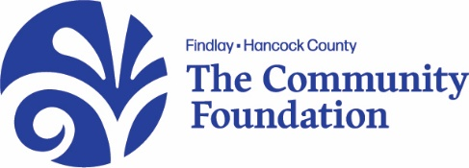
PROJECT REPORT FORM
Date Submitted:
- Annually: Grant Report Cover Sheet, Grant Report Project Budget, Grant Project Narrative Report and updated Logic Model Guide.
- Mid-year discussion or site visit with Community Foundation staff to discuss project progress.
I. Project Information:
- What did we do? What have been the principal accomplishments of the project to date? How have they been achieved? How have the grant funds been used?

- How well did we do it? Please summarize your original expected outcomes for this project and how you had planned to achieve them.

- What difference did it make? Describe the impact of your project and explain the outcomes achieved or progress towards achieving outcomes that are summarized on the attached Logic Model Template Reporting Form. Narrative information could include success stories from clients served, community partners, or agency staff. If applicable, please include quotes from anyone impacted by this project.

- When will we see the changes initiated through this program?

- Opportunities for shared learning. What have been the most challenging or surprising aspects of this project? Have there been any unexpected outcomes?

- Please describe your post-grant plans for this project. How will it be sustained?

II. Attachments (Optional)
Please attach copies of any public recognition, awards, news releases or news articles pertinent to this project. We especially encourage you to send photos and short videos. We like to use these to promote both your worthy project and our grantmaking efforts in our annual report and on our website. You can send digital files to gfreed@community-foundation.com.

